Vacuum Cleaner Problem
Aim
To implement the Vacuum Cleaner Problem using Python and simulate a simple intelligent agent that cleans all dirty rooms.
Objective
- To understand the concept of an intelligent agent.
- To simulate the working of a vacuum cleaner agent.
- To clean dirty rooms automatically.
- To display the status of each room before and after cleaning.
Algorithm
- Start the program.
- Read the status of Room A and Room B from the user (Dirty or Clean).
- Check Room A.
- If Room A is dirty, clean it.
- Move to Room B.
- If Room B is dirty, clean it.
- Display the final status of both rooms.
- Stop the program.

Code:
print("=" * 60)
print(" ARTIFICIAL INTELLIGENCE LAB")
print(" Experiment: Vacuum Cleaner Problem")
print(" Name : Vinnarasu R")
print(" Reg No : 192411040")
print("=" * 60)

A = input("Enter Room A status (Dirty/Clean): ")
B = input("Enter Room B status (Dirty/Clean): ")

print("\nInitial State")
print("Room A =", A)
print("Room B =", B)

print("\nVacuum starts at Room A")

if A.lower() == "dirty":
print("Room A is Dirty")
print("Cleaning Room A...")
A = "Clean"
else:
print("Room A is already Clean")

print("\nMove to Room B")

if B.lower() == "dirty":
print("Room B is Dirty")
print("Cleaning Room B...")
B = "Clean"
else:
print("Room B is already Clean")

print("\nFinal State")
print("Room A =", A)
print("Room B =", B)

print("\nAll rooms are clean.")
Output:
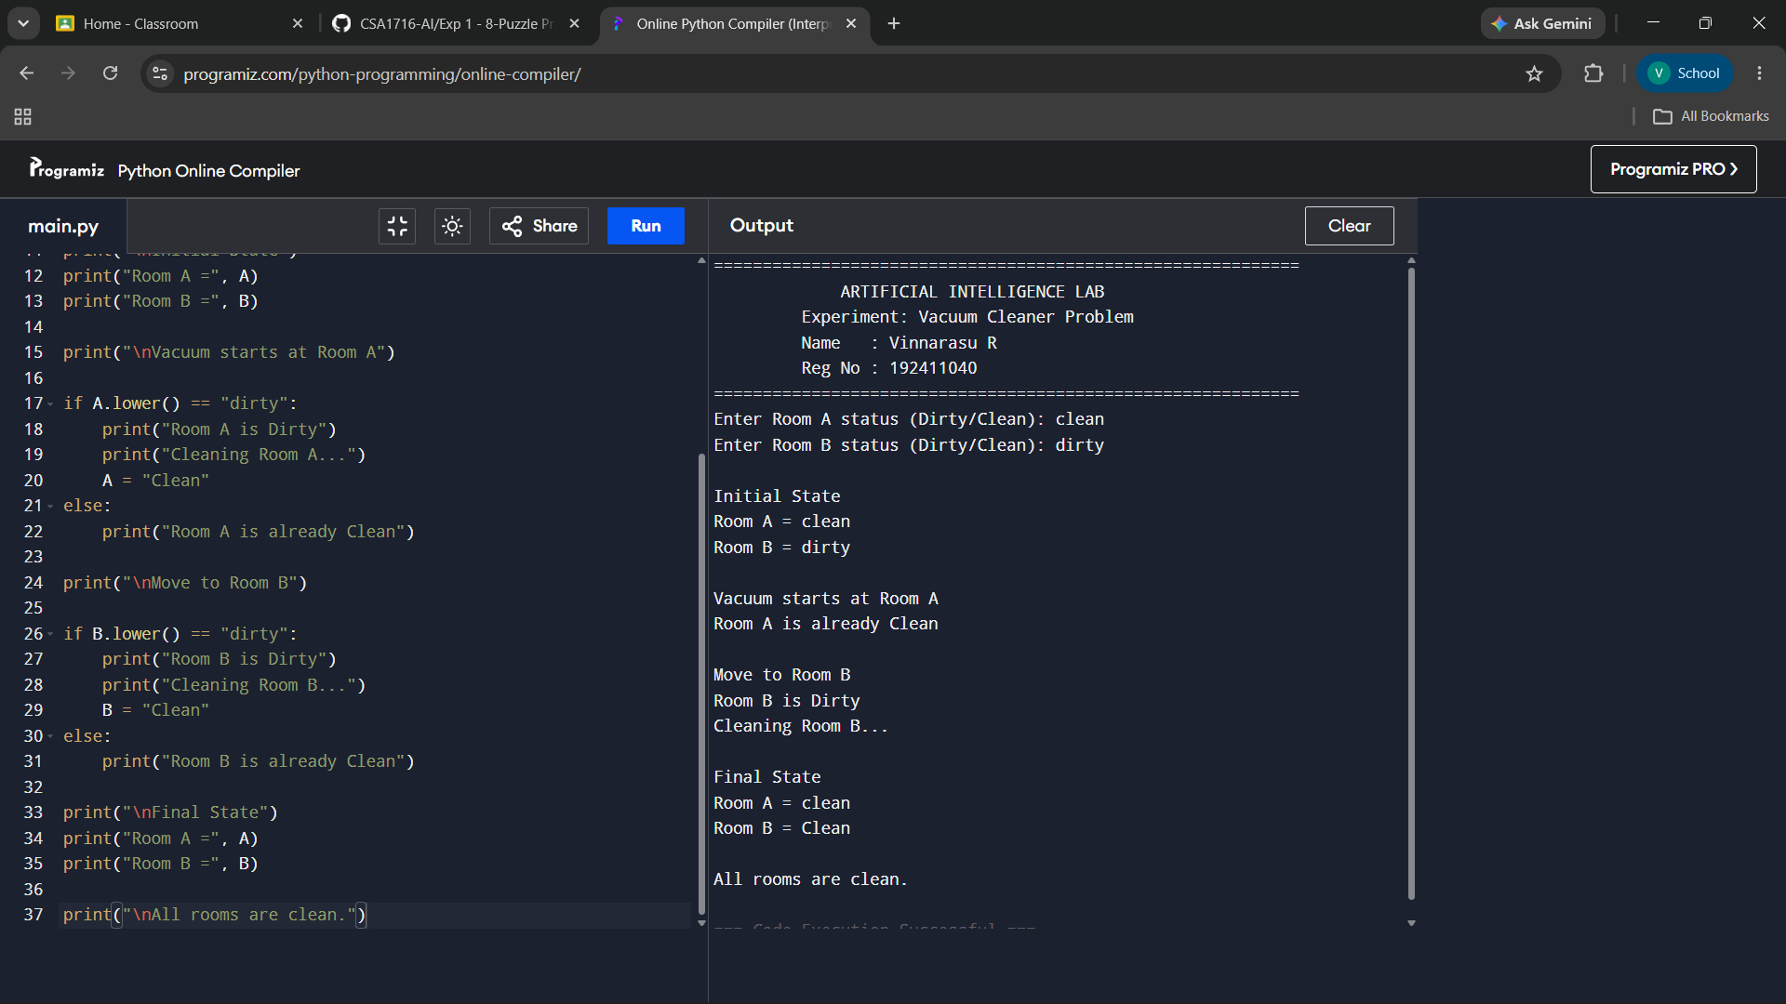
Result:
The Vacuum Cleaner Problem was implemented successfully in Python. The program accepted the status of two rooms, cleaned the dirty rooms automatically, and displayed the final status, demonstrating the behavior of a simple intelligent agent.

